Final Classification Report

1. Data Split Summary
Subset | Count | Ratio
Training | 29358 | 70%
Validation | 6291 | 15%
Testing | 6291 | 15%

2. Best Model Selection
The best performing model, selected based on the highest Comprehensive Average Score (mean of Accuracy, ROC-AUC, Macro F1, AI F1, Human F1, and Human Recall), is: Random Forest with an average score of 0.6272.

3. Model Metrics Summary (Sorted by Average Score)
Model | Accuracy | ROC-AUC | Macro F1-Score | F1-Score (AI) | F1-Score (Human) | Recall (Human) | Average_Score
Naive Bayes | 0.8617 | 0.6932 | 0.4674 | 0.9257 | 0.0091 | 0.0046 | 0.4936
Logistic Regression | 0.8609 | 0.7036 | 0.4737 | 0.9251 | 0.0223 | 0.0115 | 0.4995
Random Forest | 0.8034 | 0.7679 | 0.6107 | 0.8846 | 0.3367 | 0.3601 | 0.6272
SVM | 0.8614 | 0.4708 | 0.4628 | 0.9255 | 0.0000 | 0.0000 | 0.4534
XGBoost | 0.8614 | 0.6953 | 0.4639 | 0.9255 | 0.0023 | 0.0011 | 0.4916
Feedforward NN + BERT (768D) | 0.8617 | 0.7056 | 0.4674 | 0.9257 | 0.0091 | 0.0046 | 0.4957

4. Best Model Detailed Report
Metric | precision | recall | f1-score | support
AI | 0.8947 | 0.8747 | 0.8846 | 5419.0000
Human | 0.3162 | 0.3601 | 0.3367 | 872.0000
accuracy | 0.8034 | 0.8034 | 0.8034 | 0.8034
macro avg | 0.6054 | 0.6174 | 0.6107 | 6291.0000
weighted avg | 0.8145 | 0.8034 | 0.8086 | 6291.0000

5. Performance Benchmark Plot (Key Metrics + Average)
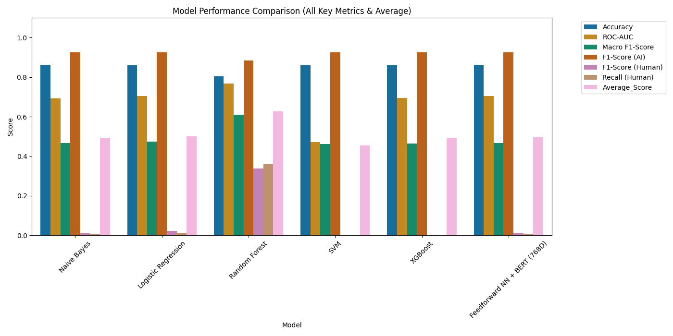

6. ROC Curves (All Models)
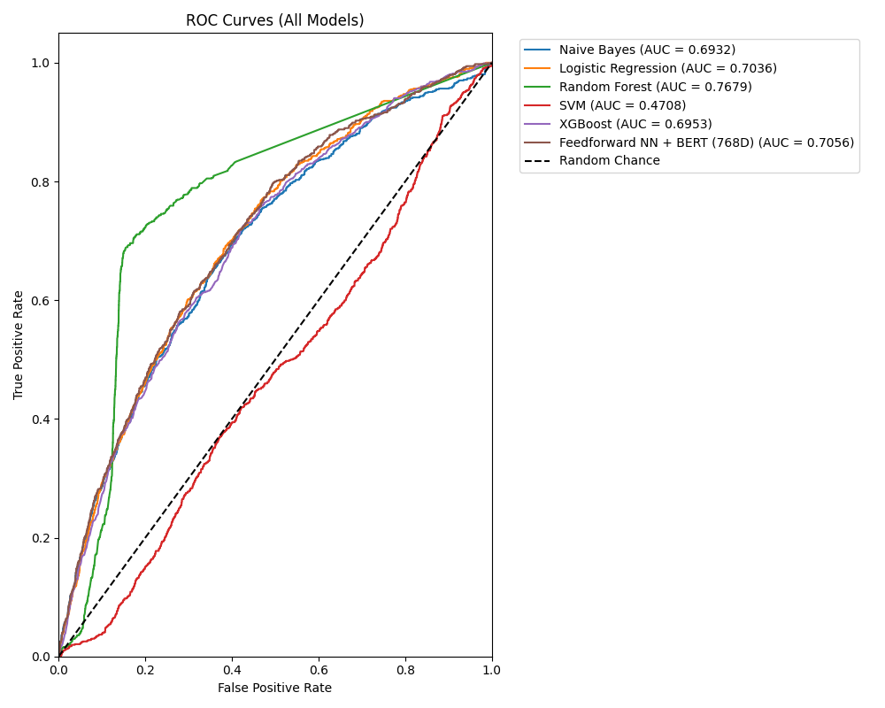

7. Model Analysis (Confusion Matrix + Error Confidence)

Model: Naive Bayes
Confusion Matrix:
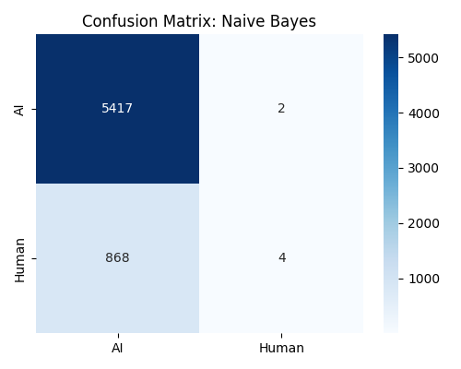
Error Confidence Analysis:
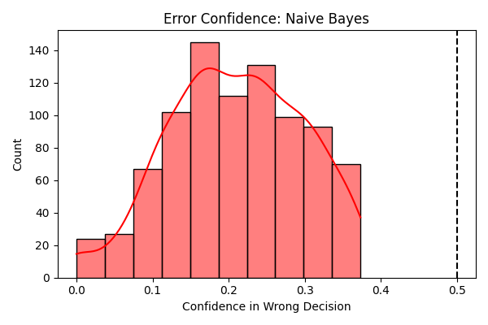

Model: Logistic Regression
Confusion Matrix:
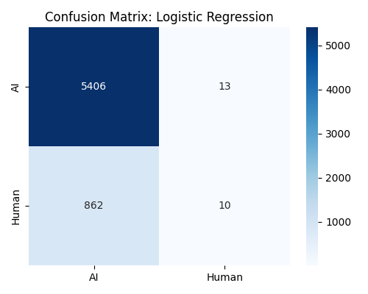
Error Confidence Analysis:
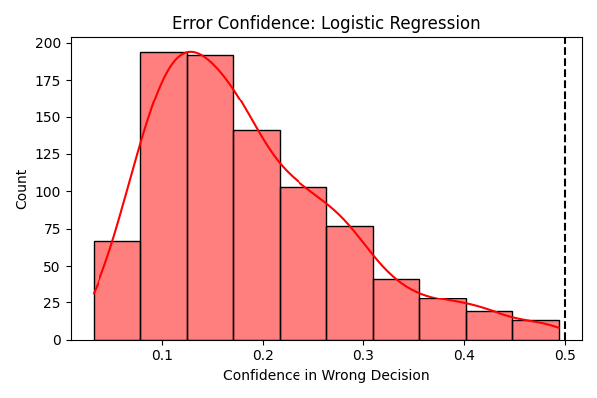

Model: Random Forest
Confusion Matrix:
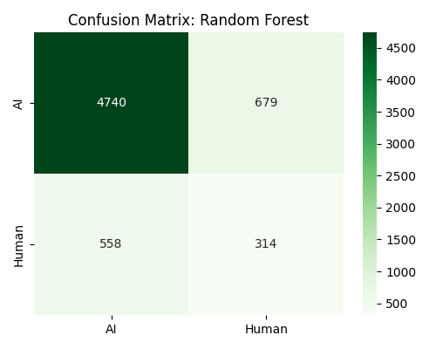
Error Confidence Analysis:
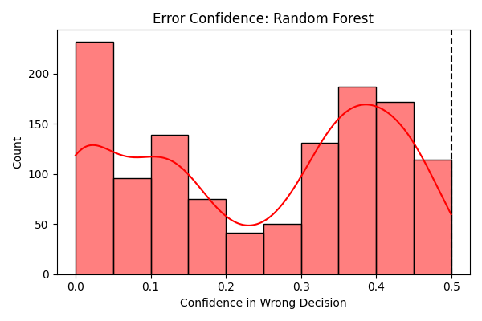

Model: SVM
Confusion Matrix:
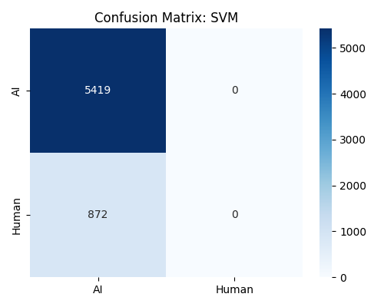
Error Confidence Analysis:
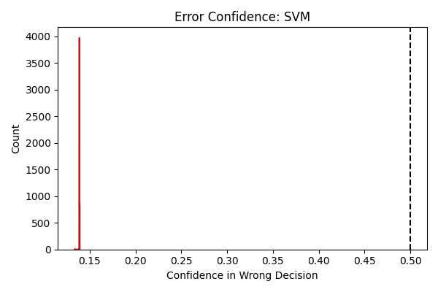

Model: XGBoost
Confusion Matrix:
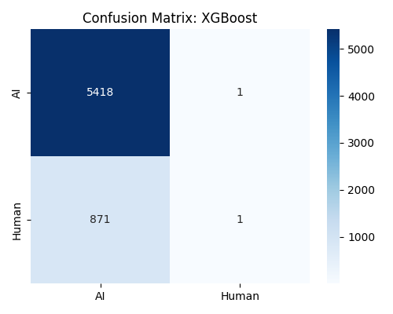
Error Confidence Analysis:
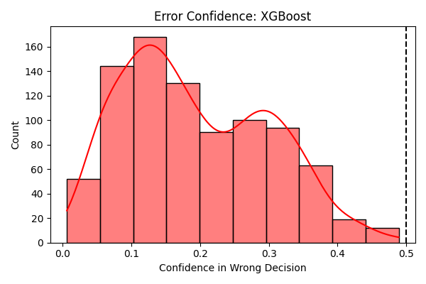

Model: Feedforward NN + BERT (768D)
Confusion Matrix:
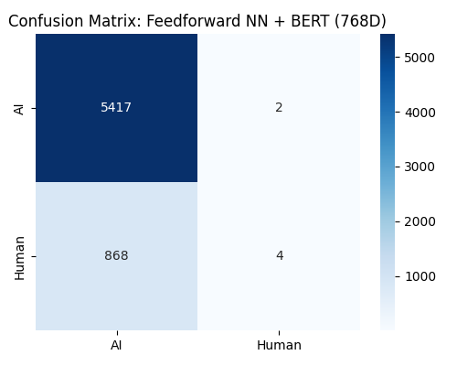
Error Confidence Analysis:
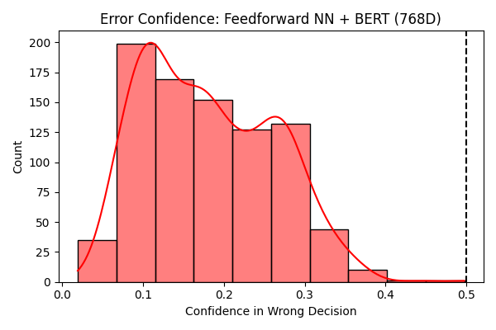

8. Feature Importance (Best Tree-Based Model)
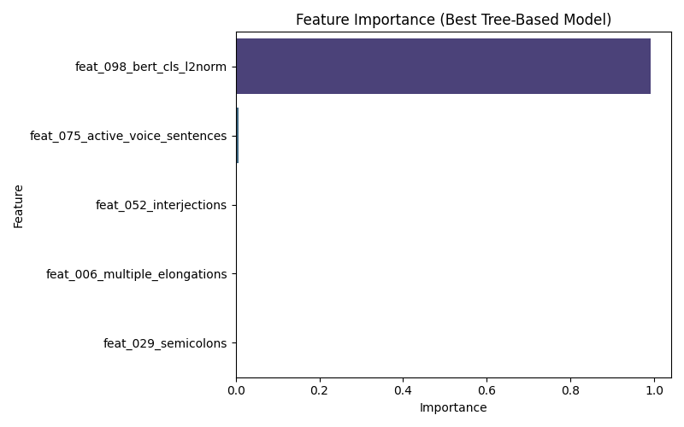

9. Neural Network Training History
